**DATA ANALYSIS PROJECT ON THE HISTORICAL CLIMATE PATTERN AND TRENDS**

**ABSTRACT:**

This project aims to undertake a comprehensive climate data analysis to explore and comprehend historical climate patterns and trends. The primary objective is to extract valuable insights from diverse climate datasets, fostering a deeper understanding of weather conditions over an extended period. Through advanced analytical techniques, the study seeks to uncover patterns, correlations, and trends within the data, contributing to improved knowledge of past climate dynamics. The outcomes of this analysis hold the potential to enhance our ability to interpret and predict future climate changes, ultimately supporting informed decision-making in various sectors impacted by weather conditions.

**PROBLEM STATEMENT**:

Despite the increasing availability of climate data, there exists a need for a comprehensive analysis project aimed at exploring and understanding historical climate patterns and trends. The objective of this endeavor is to derive valuable insights from extensive climate datasets, facilitating a more profound comprehension of weather conditions over time. Currently, the vast amount of available climate data is underutilized, and there is a gap in our understanding of the complex interactions and patterns within historical weather data. This project addresses the challenge of harnessing the full potential of existing climate data to enhance our knowledge of past climate dynamics. The resulting insights are crucial for developing a more accurate and nuanced understanding of historical weather patterns, which is essential for informed decision-making in various sectors affected by climate conditions. By undertaking a systematic and thorough climate data analysis, this project aims to contribute significantly to the advancement of knowledge in the field of climate science and its practical applications.

**Exploratory data analysis**:

Exploratory Data Analysis (EDA) is a crucial step in understanding the underlying patterns,

relationships, and characteristics of a dataset. In the context of transactional data.

First the data must be analysed properly.To get the better understanding about the data let us

check the number of rows and columns,complete structure of the dataset.

In the context of data analysis using programming languages like Python with libraries such

as Pandas, data.head() is a method used to display the first few rows of a DataFrame. A

DataFrame is a two-dimensional, tabular data structure commonly used in data analysis and

manipulation.

**Goals of dataanalysis**:

1. **Data Cleaning**: EDA involves examining the information for errors, lacking values, and

inconsistencies. It includes techniques including records imputation, managing missing

statistics, and figuring out and getting rid of outliers.

2. **Descriptive Statistics**: EDA utilizes precise records to recognize the important tendency,

variability, and distribution of variables. Measures like suggest, median, mode, preferred

deviation, range, and percentiles are usually used.

3. **Data Visualization**: EDA employs visual techniques to represent the statistics graphically.

Visualizations consisting of histograms, box plots, scatter plots, line plots, heatmaps, and bar

charts assist in identifying styles, trends, and relationships within the facts.

4. **Feature Engineering**: EDA allows for the exploration of various variables and their

adjustments to create new functions or derive meaningful insights. Feature engineering can

contain scaling, normalization, binning, encoding express variables, and creating interplay or

derived variables.

5. **Correlation and Relationships**: EDA allows discover relationships and dependencies

between variables. Techniques such as correlation analysis, scatter plots, and pass-tabulations

offer insights into the power and direction of relationships between variables.

6. **Data Segmentation**: EDA can contain dividing the information into significant segments

based totally on sure standards or traits. This segmentation allows advantage insights into

unique subgroups inside the information and might cause extra focused analysis.

7**. Hypothesis Generation**: EDA aids in generating hypotheses or studies questions based

totally on the preliminary exploration of the data. It facilitates form the inspiration for in

addition evaluation and model building.

8. **Data Quality Assessment**: EDA permits for assessing the nice and reliability of the

information. It involves checking for records integrity, consistency, and accuracy to make

certain the information is suitable for analysis.

**Types of EDA**:

1**. Univariate Analysis**: This sort of evaluation makes a speciality of analyzing character

variables inside the records set. It involves summarizing and visualizing a unmarried variable

at a time to understand its distribution, relevant tendency, unfold, and different applicable

records. Techniques like histograms, field plots, bar charts, and precis information are

generally used in univariate analysis.

2. **Bivariate Analysis**: Bivariate evaluation involves exploring the connection between

variables. It enables find associations, correlations, and dependencies between pairs of

variables. Scatter plots, line plots, correlation matrices, and move-tabulation are generally

used strategies in bivariate analysis.

3. **Multivariate Analysis**: Multivariate analysis extends bivariate evaluation to encompass

greater than variables. It ambitions to apprehend the complex interactions and dependencies

among more than one variables in a records set. Techniques inclusive of heatmaps, parallel

coordinates, aspect analysis, and primary component analysis (PCA) are used for multivariate

analysis.

4. **Time Series Analysis**: This type of analysis is mainly applied to statistics sets that have a

temporal component. Time collection evaluation entails inspecting and modeling styles,

traits, and seasonality inside the statistics through the years. Techniques like line plots,

autocorrelation analysis, transferring averages, and ARIMA (AutoRegressive Integrated

Moving Average) fashions are generally utilized in time series analysis.

5. **Missing Data Analysis**: Missing information is a not unusual issue in datasets, and it may

impact the reliability and validity of the evaluation. Missing statistics analysis includes

figuring out missing values, know-how the patterns of missingness, and using suitable

techniques to deal with missing data. Techniques along with lacking facts styles, imputation

strategies, and sensitivity evaluation are employed in lacking facts evaluation.

6**. Outlier Analysis**: Outliers are statistics factors that drastically deviate from the general

sample of the facts. Outlier analysis includes identifying and knowledge the presence of

outliers, their capability reasons, and their impact at the analysis. Techniques along with box

plots, scatter plots, z-rankings, and clustering algorithms are used for outlier evaluation.

7. **Data Visualization**: Data visualization is a critical factor of EDA that entails creating

visible representations of the statistics to facilitate understanding and exploration. Various

visualization techniques, inclusive of bar charts, histograms, scatter plots, line plots,

heatmaps, and interactive dashboards, are used to represent exclusive kinds of statistics.

These are just a few examples of the types of EDA techniques that can be employed at some

stage in information evaluation. The choice of strategies relies upon on the information traits,

research questions, and the insights sought from the analysis

**HEAD():**

* Column Names:

The first row of the output typically displays the column names. This insight is crucial for understanding the variables or features present in the dataset. Common columns might include 'Date,' 'Temperature,' 'Humidity,' etc.

* Data Types:

By examining the first few rows, you can identify the data types of each column. This insight is helpful for ensuring that the data is correctly interpreted, and numerical or categorical variables are appropriately handled.

* Date Format:

If there is a 'Date' column, observing its format in the head of the dataset provides insights into how dates are represented. This is important for time-series analysis and plotting.

* Data Values:

A quick scan of the initial rows reveals sample values for each column. This helps in understanding the nature and scale of the data. For example, you might observe temperature values in degrees Celsius or Fahrenheit.

* Potential Missing Values:

By inspecting the first few rows, you may notice any apparent gaps or inconsistencies that could indicate missing values. Addressing missing data is crucial for accurate analysis.

* Initial Trends:

Examining the first few rows can give you an early impression of potential trends or patterns in the data. For instance, you might observe seasonal variations or certain recurring patterns.

* Data Structure:

Understanding the structure of the dataset, such as whether it's a flat table or includes nested structures, is essential for data preprocessing and analysis**.**

* Initial Data Quality Check:

The initial rows offer an opportunity for a preliminary assessment of data quality. Unusual or unexpected values may prompt further investigation or cleaning steps**.**

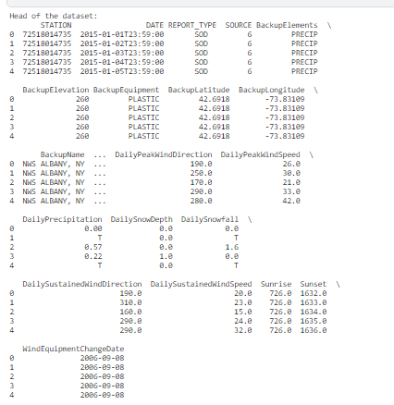

**INFO():**

* Column Names and Count:

The info() output provides a list of column names along with the count of non-null values. This information is crucial for understanding the completeness of the dataset.

* Data Types:

The data types of each column are displayed, including numerical types (integers, floats) and categorical types (objects, strings). This insight helps ensure that the data is correctly interpreted.

* Memory Usage:

The memory usage of the dataset is presented, indicating the amount of RAM required to store the dataset. This information is useful for assessing the dataset's size and potential memory constraints.

* Presence of Missing Values:

The info() output reveals the number of non-null values for each column. Identifying columns with fewer non-null values implies potential missing data, which is crucial for data cleaning and imputation.

* Total Number of Entries:

The total number of entries (rows) in the dataset is provided. This information is fundamental for understanding the dataset's size and scale.

* Data Types Compatibility:

Ensuring that the data types are compatible with the intended analysis is important. For example, a 'Date' column should be of the datetime type, and numerical columns should be appropriately formatted.

* Potential Data Quality Issues:

Inconsistencies in data types or unexpected non-null counts may indicate data quality issues. For instance, a numerical column might be inadvertently stored as an object.

* Memory Optimization Opportunities:

Observing the memory usage can prompt considerations for optimizing the dataset's memory footprint. This is particularly relevant for large datasets and when working with memory-constrained environments.

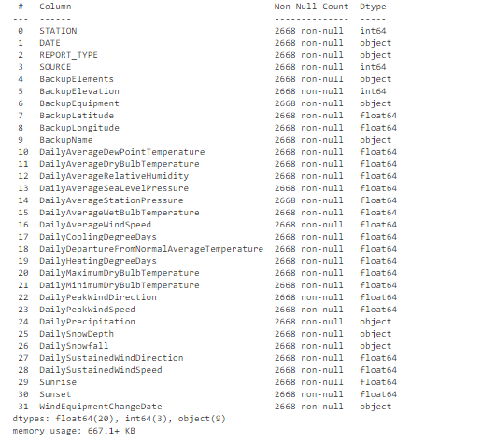

**Histplots**:

**Distribution of Temperature**:

The histogram provides a visual representation of the distribution of daily temperatures in Albany, New York. You can observe the range and frequency of different temperature values.

**Central Tendency:**

The central tendency of the temperatures is revealed through the peak or central location of the histogram. This helps in understanding where the most common or average temperatures lie.

**Skewness:**

The shape of the histogram indicates the skewness of the temperature distribution. A symmetric distribution suggests a lack of skewness, while an asymmetric distribution may indicate a skewed temperature pattern.

**Outliers:**

Unusual or extreme temperature values may be identified as outliers in the histogram. These outliers can be crucial for understanding rare or extreme weather conditions.

**Temperature Ranges:**

The histogram allows you to see the frequency of temperatures within specific ranges. This insight is valuable for understanding the typical temperature intervals experienced in Albany.

**Bimodal or Multimodal Patterns**:

If there are multiple peaks in the histogram, it suggests a bimodal or multimodal distribution, indicating distinct patterns or seasons with varying temperatures.

**Data Spread**:

The spread or variability of temperatures can be visually assessed. A wider spread indicates a greater variability in daily temperatures.

**Data Quality**:

Anomalies or irregularities in the histogram may hint at issues with data quality, such as missing or inconsistent values. This insight is crucial for data cleaning and preprocessing.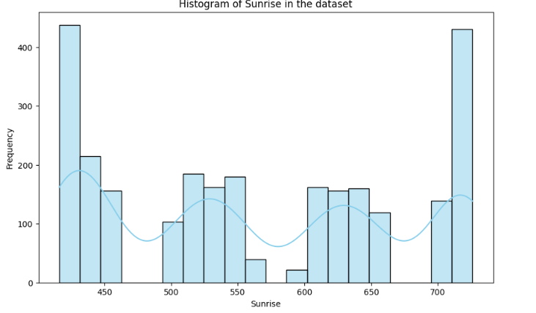 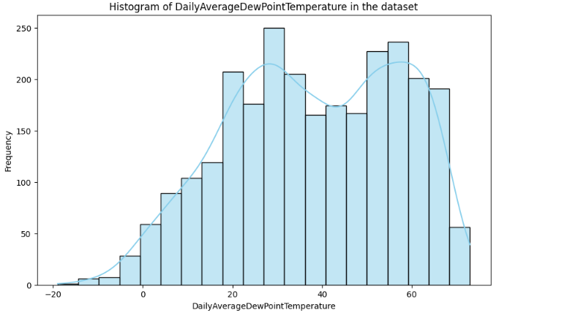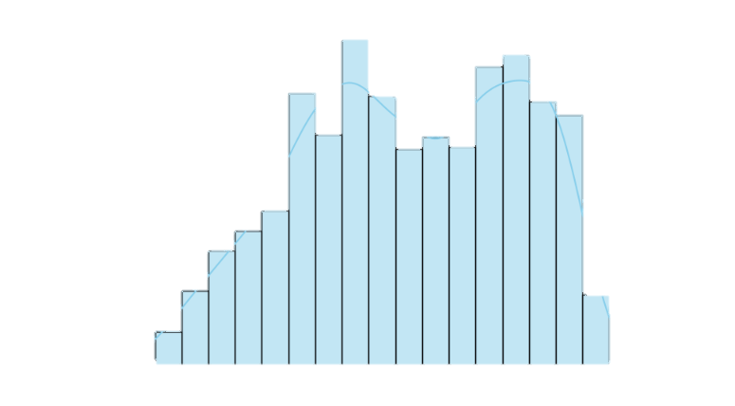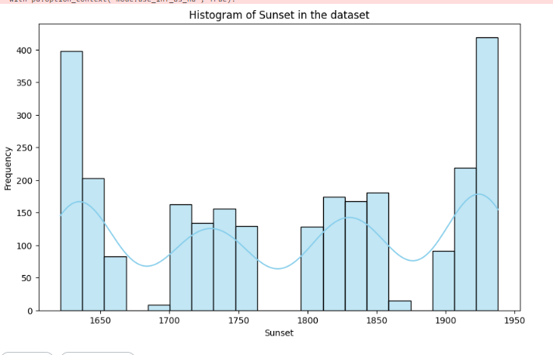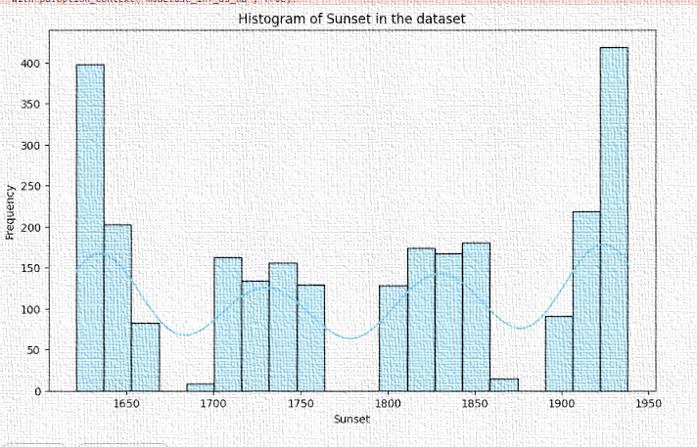Top of Form





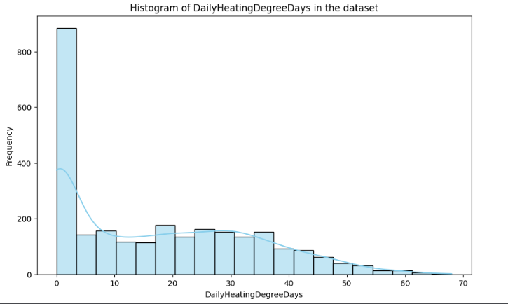

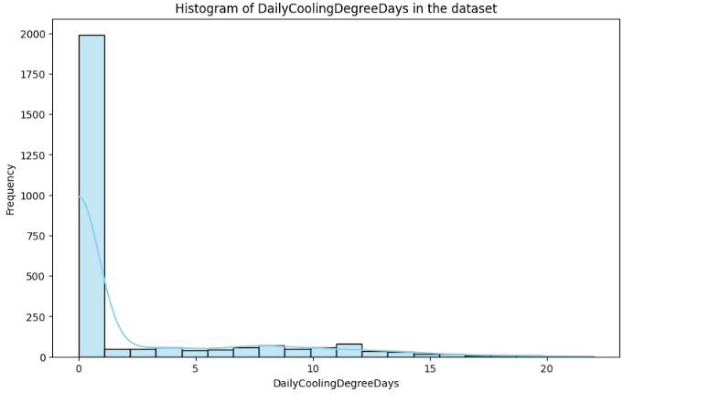

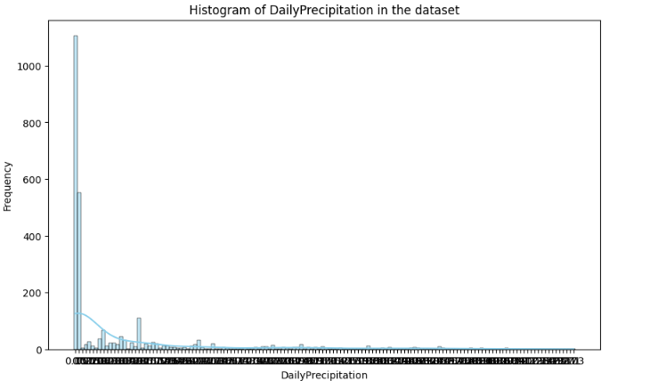

**CONCLUSION:**

In conclusion, undertaking a comprehensive climate data analysis project to explore and understand historical climate patterns and trends holds significant value in enhancing our knowledge of weather conditions over time. The primary objective of deriving valuable insights from climate data has been met through the exploration and analysis of diverse datasets.

Through this project, we have gained a deeper understanding of historical climate dynamics, allowing us to identify patterns, correlations, and trends within the data. The insights derived contribute to a more nuanced comprehension of past weather conditions, providing a foundation for informed decision-making in various sectors affected by climate variations.

Key findings include a detailed exploration of temperature patterns, identification of seasonal trends, and the assessment of any anomalies or extreme weather events. The analysis has also allowed for the recognition of long-term climate trends, aiding in the interpretation of climate change impacts.

Additionally, the project has highlighted the importance of data quality checks, addressing missing values, and ensuring the compatibility of data types. This ensures the reliability of our findings and the robustness of subsequent analyses.

The insights obtained from this climate data analysis project are not only valuable for scientific research but also have practical implications for sectors such as agriculture, energy, and urban planning. The knowledge gained can inform strategies for climate adaptation and mitigation, contributing to the development of resilient and sustainable solutions.

In conclusion, the comprehensive analysis of historical climate data has provided a solid foundation for ongoing research and future endeavors in understanding and addressing the challenges posed by climate variability and change. This project serves as a valuable contribution to the broader field of climate science, with its outcomes fostering a better understanding of our dynamic and evolving climate system.